Competitive Shooters of Lake Norman USPSA April 9th, 2026
COURSE DESIGNER: Rocky Perillo

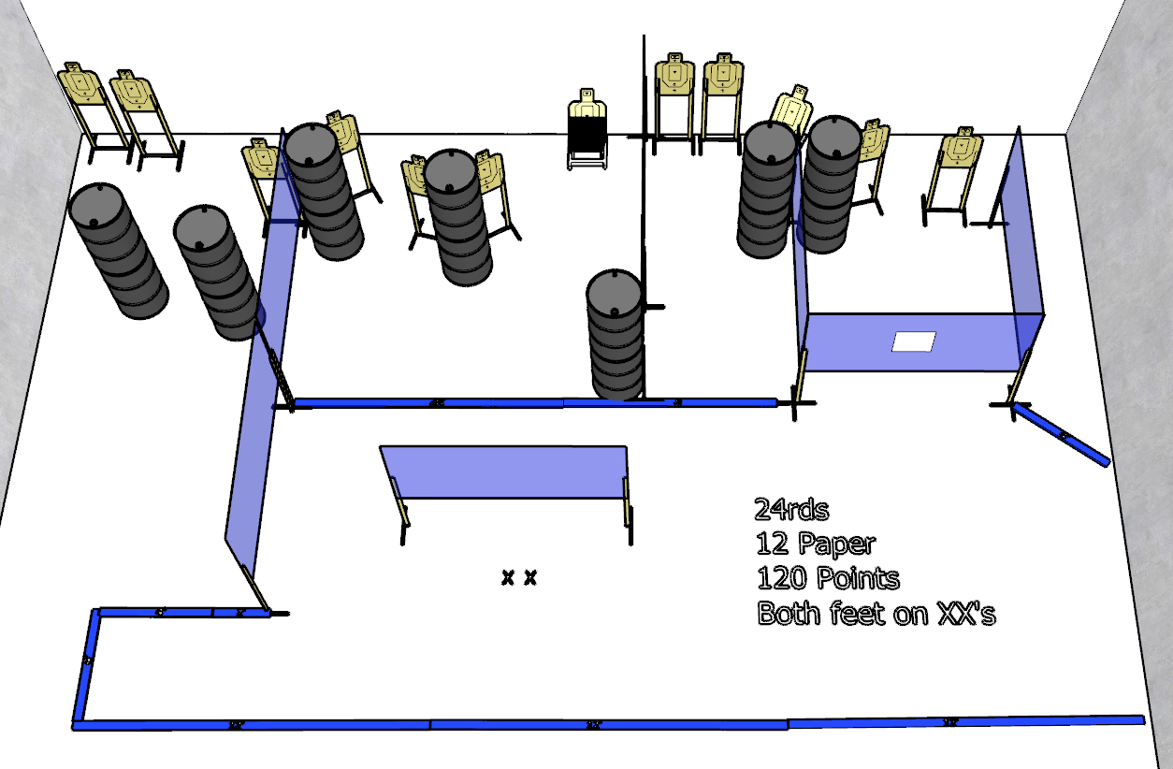

Stage 3 - Ezekiel!
24 rounds, 120 points, Comstock
There are 12 cardboard targets.
Starting with both feet on XXs.
Handgun is loaded and holstered, wrists below belt.
PCC is loaded, held in both hands, stock touching belt.
On the audible start signal, engage targets from within the shooting area.

